Dis-Pac-Poly-Necklace-Shell-woven clasp

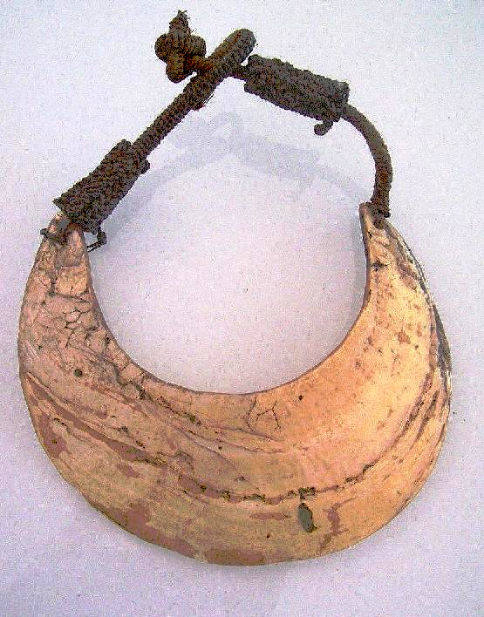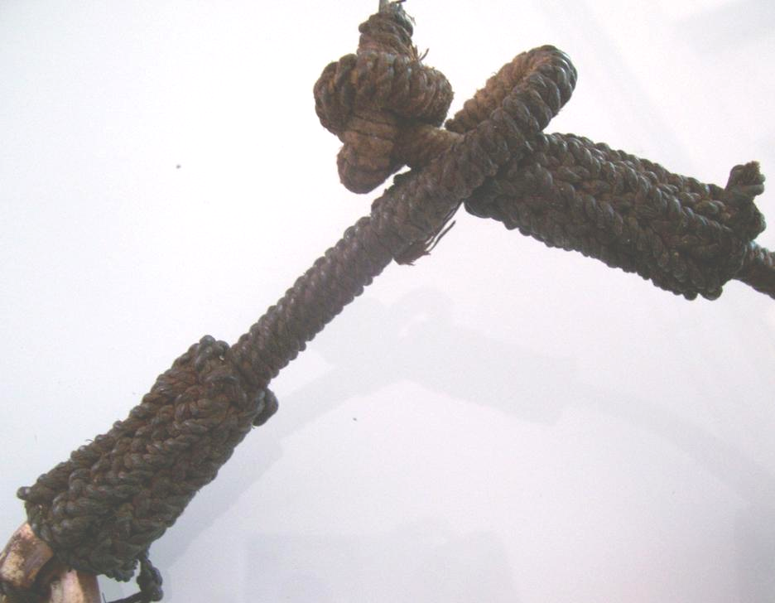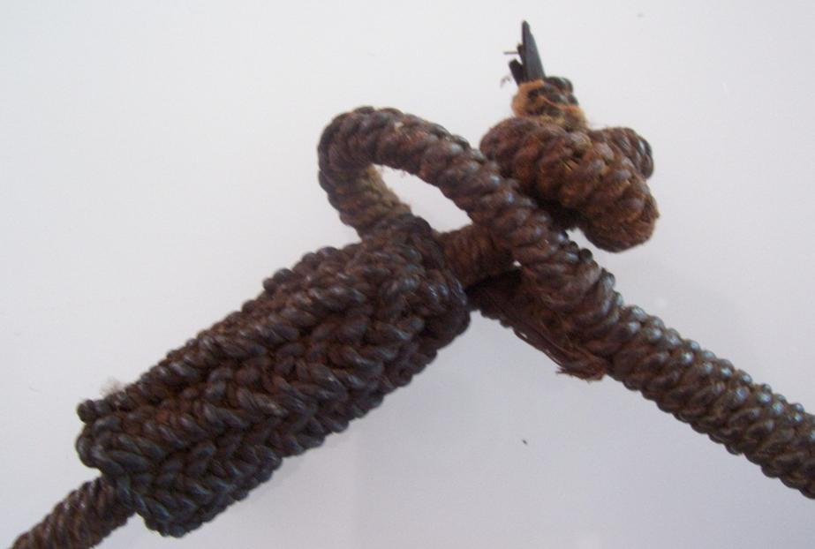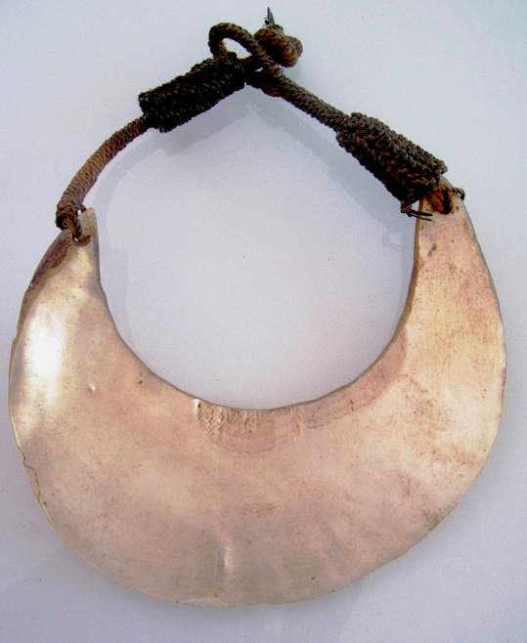

# Order details

## Sales order

Sold by [lebaroudeurchine...](http://myworld.ebay.com/lebaroudeurchineur) ( [1266](http://feedback.ebay.com/ws/eBayISAPI.dll?ViewFeedback&userid=lebaroudeurchineur) )

### Delivery package 1 of 1

Estimated delivery Tuesday, Sep 27, 2016 - Wednesday, Oct 5, 2016

#### [Old necklace.Oceania papouasie tribal art primitif premier](http://www.ebay.com/itm/321691993545)

|  |  |
| --- | --- |
| Item price | $380.00 |
| Quantity | 1 |
| Item number | 321691993545 |
| Shipping service | Standard Shipping from outside US |

## Shipping address

Ralph J Coffman Jr

149 Atlantic Ave

Swampscott MA 01907-2427

United States

## Order total

|  |  |
| --- | --- |
| Subtotal | $380.00 |
| Shipping | Free |

**Total**

$380.00